Tasks

1.Pick any one public place near your college (e.g., bus stop, chai tapri, or college canteen) and design a guerrilla marketing idea to promote a new local food delivery app. Describe the concept, what props or materials you would use, and how it would surprise or engage people.

2.Create a simple sketch or digital mockup of a guerrilla marketing poster or installation for an upcoming music festival, using elements that would catch attention in a crowded street or mall.<br><br><em><strong>Hint:</strong> Think about using 3D objects, interactive elements, or optical illusions to make your design stand out.</em>

3.Analyze a recent guerrilla marketing campaign from any Indian brand (e.g., Zomato, Cred, Swiggy, or an IPL team) and list 3 reasons why it worked or failed, focusing on creativity, location, and audience reaction.

4.Imagine you are launching a new student discount card for local shops. Plan a flash mob or surprise event as a guerrilla marketing stunt on your campus. Write a step-by-step plan including location, timing, participants, and how you will capture and share the event on social media.

Answer:-

1. Guerrilla marketing idea: Food-delivery app
Public place selected: College ke paas wali chai tapri / bus stop
New food-delivery app name: BhookhBuster
Campaign name: “Wait Mat Karo, Bite Karo!”

Concept
Bus stop ya chai tapri ke paas ek fake giant food-delivery bag installation lagaya jayega. Bag ko aise design karenge jaise woh open ho raha ho aur uske andar se giant burger, pizza slice, biryani bowl aur fries bahar aa rahe hon.
Bag ke front par likha hoga:

Bus Ka Wait Theek Hai… Bhookh Ka Nahi!
Neeche QR code hoga:
“Scan karo aur first order par ₹75 OFF pao!”

Props/materials required
- Large cardboard/thermocol food-delivery bag
- 3D fake burger, pizza, fries aur biryani props
- Bright yellow-red branding stickers
- Waterproof QR-code board
- Floor stickers shaped like fries/pizza slices
- Small promotional standee
- Branded T-shirts pehne 2–3 volunteers
- Coupon cards with code: BHOOKH75

How it will surprise people
- Normal bus stop ya chai stall ke paas ek oversized food bag unexpected lagega, isliye people rukkar dekhenge.
- Floor stickers logon ko installation tak guide karenge: “Follow the fries if you’re hungry!”
- Volunteer ek small “Hunger Meter” board lekar khade honge: “Aapki bhookh kitni hai? Low / Medium / Emergency!”
- “Emergency Hunger” select karne walon ko instant coupon ya snack sample milega.
- Students photo click karke Instagram/WhatsApp par share karenge, jisse word-of-mouth promotion hoga.
Guerrilla marketing ka main idea unconventional, low-cost aur surprise-based execution hota hai—jaise street installations, clever everyday placements aur QR-based immediate action.cupshup.co+1

2. Music-festival guerrilla poster mockup
Festival name: BEATSTORM 2026
Tagline: “Feel the Bass. Own the Night.”

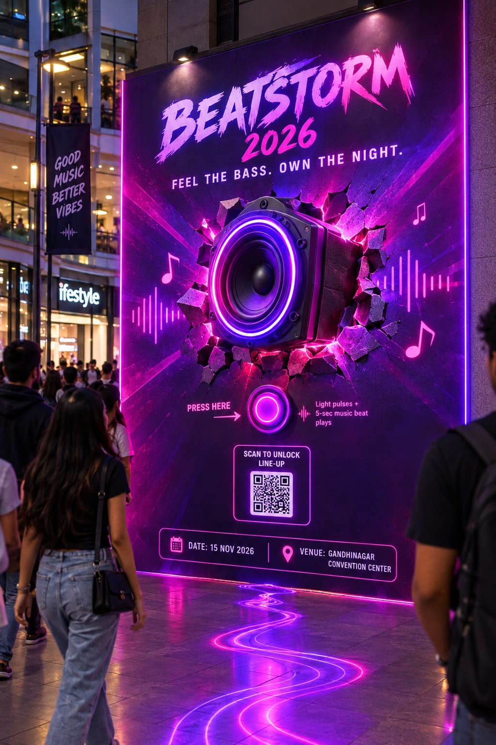

Attention-grabbing elements
- 3D optical illusion: Large speaker aisa lagega jaise wall todkar bahar aa raha ho.
- Interactive button: Log “Press for Bass” button press karenge, toh small music beat aur LED pulse effect chalega.
- Neon lighting: Purple, pink aur electric-blue lights crowded street ya mall mein poster ko stand out karayengi.
- Sound-wave floor stickers: Walking path par wave-shaped stickers lagaye jayenge, jo logon ko poster tak le jayenge.
- QR code: QR scan karne par event lineup, ticket offer aur playlist open hogi.
- Photo opportunity: Poster ke side par text hoga: “Caught in the Beat!” Taaki people selfies/reels banayein.

3. Guerrilla campaign analysis
Brand selected: Zomato
Campaign: Zomato ke witty, hyperlocal billboard campaigns
Zomato ne Delhi, Mumbai, Bengaluru aur Pune jaise cities mein topical billboards use kiye, jinke short humorous lines local weather, season aur city mood se related hote the. Example: Delhi winter context mein “Fog toh hai, hunger bhi hai.” Is type ki copy outdoor space ko social-media-shareable content bana deti hai.

3 reasons why it worked
- Creative and simple messaging
Billboard copy short, funny aur conversational thi. Log driving ya traffic mein bhi message quickly read kar sakte the. Yeh traditional long advertisement jaisa nahi lagta, balki meme ya tweet jaisa feel deta hai.
- Right location and local context
High-traffic roads aur city-specific environments mein billboard place karne se daily commuters ne message dekha. Local weather, traffic ya festival reference hone se ad zyada relatable laga. Zomato ki hyperlocal copy city ke mood aur seasonal moments ko use karti thi.
- Audience reaction and social sharing
Humour aur unexpected line ki wajah se log billboard ki photo lekar Instagram, WhatsApp aur X par share karte hain. Isliye ek physical billboard offline audience ke saath-saath online audience tak bhi pahunchta hai. Similar short, conversational Zomato-Blinkit billboard exchanges ko bhi “advertising” ke bajay funny brand conversation jaisa perceive kiya gaya.

Possible limitation
Agar joke too subtle ho, local reference samajh na aaye, ya billboard ke paas traffic fast ho, toh audience message miss kar sakti hai. Isliye guerrilla ad ka message simple, visible aur safe hona chahiye.

4. Student discount-card flash mob plan
Card name: CampusSaver Card
Tagline: “Student Ho? Savings Toh Banti Hai!”

Step-by-step plan
- Location selection
Flash mob ko college central courtyard, canteen ke outside area ya main gate ke near organise karenge, kyunki lunch break mein yahan highest footfall hota hai.
- Timing
Event ko 12:30 PM–1:00 PM ke beech organise karenge, jab students lunch break ke liye free hote hain. Permission college administration se pehle li jayegi.
- Participants
12–15 dancers/volunteers, 2 hosts, 2 videographers aur 3 promotion volunteers honge. Dancers normal students ki tarah crowd mein mix hokar khade rahenge.
- Surprise start
Ek student pretend karega ki uska wallet empty hai aur woh canteen mein food buy nahi kar paa raha. Tab background mein music start hoga aur dancers flash mob begin karenge.
- Performance message
Dance ke beech posters reveal honge:
  - “Food? Fashion? Fun?”
  - “Student Ho?”
  - “Savings Toh Banti Hai!”
End mein sab participants CampusSaver Card ka large banner reveal karenge.
- Instant sign-up and reward
Flash mob ke baad volunteers QR-code standees ke through free card signup karwayenge. First 100 sign-ups ko local café/food outlet par ₹50 discount coupon milega.
- Social-media capture
Videographers multiple angles se event record karenge. Same day Instagram Reel, WhatsApp Status clip aur college groups mein video share hoga. Students ko caption diya jayega: “Main bhi #CampusSaverSquad ka part hoon!”
- Follow-up
Registration ke baad student ko WhatsApp par partner shops ki list, card benefits aur coupon code send kiya jayega. Next week, most-shared reel/post ko free shopping voucher diya jayega.

Why this stunt can work
Flash mob unexpected hota hai, isliye crowd naturally gather hota hai. Dance, relatable student-budget problem, instant reward aur QR signup ek saath attention ko actual registrations mein convert kar sakte hain.

